Chapter 4 Case Study #2

Average Family Net Worth
The Federal Reserve Bank provides an interesting data set on average family net worth and many other family and age financial metrics. Find the graph displaying the data on family net worth here: https://www.federalreserve.gov/econres/scf/dataviz/scf/chart/#series:Net_Worth;demographic:all;population:1;units:median. Note that you can interactively change the metric you use to represent “Net worth by all families” between median and mean as shown in the following graphs:

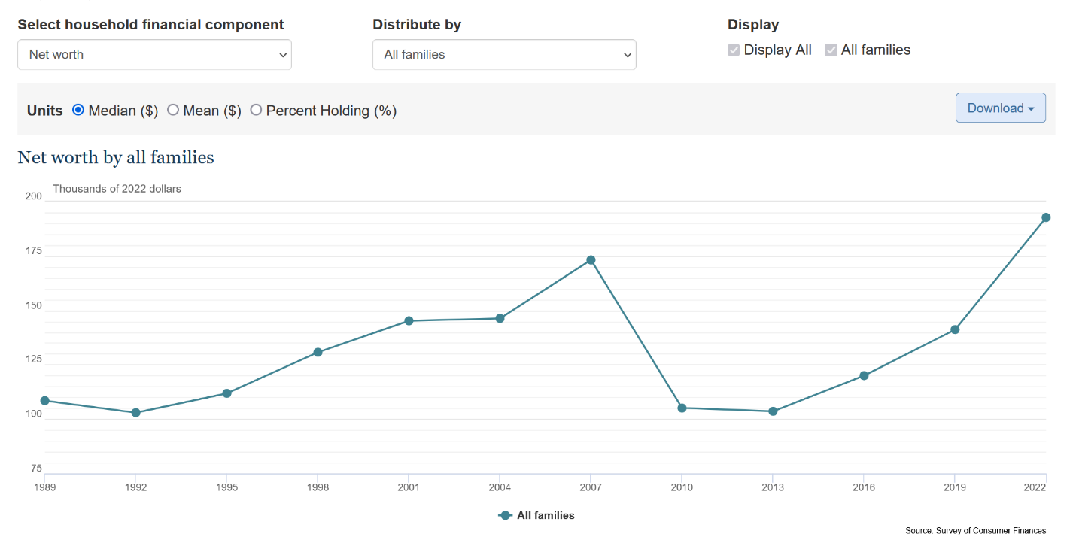

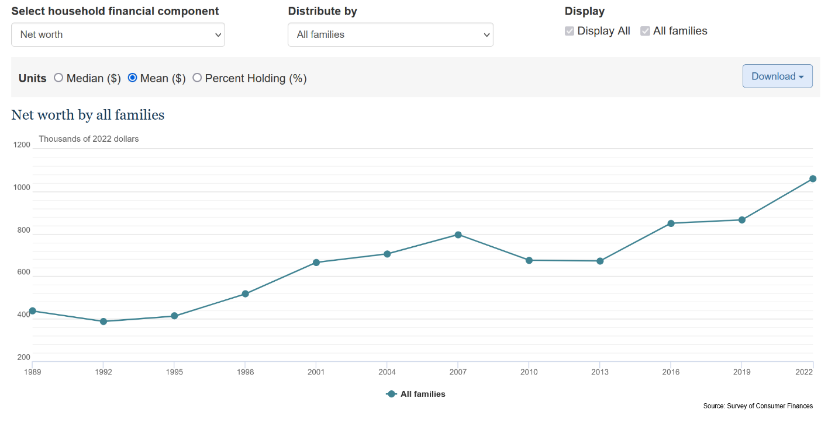

(You can also navigate there by going to www.federalreserve.gov and selecting “Economic Research” at the bottom left side of the webpage. Then, click on “Survey of Consumer Finances.” Scroll down and click on the blue button titled "View Interactive Chartbook." This website provides all sorts of interesting data about the financial state of families and persons segmented by age.)

Using this data and the knowledge you’ve garnered from Chapter 4, answer the following questions:

- Do you think there are outliers in the data that were used to calculate these statistics (metrics)?
- Based on the difference between the mean and median, is the net worth distribution for each year skewed? In which direction is the data skewed?
- Which of these graphs do you think more accurately describes the “typical” net worth of an American family? Why?
- If you were to remove the top 1% of net worths from the dataset, what effect do you think this would have on the mean and median? Explain your reasoning.

